

A distributed application manager for the CSIR

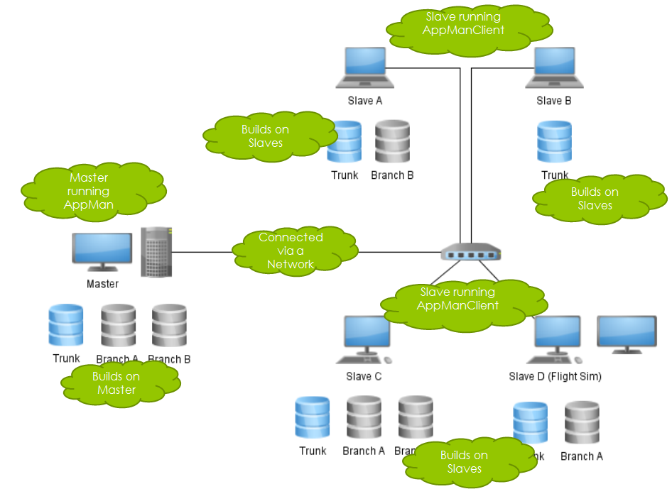

Members:

Francois Germishuizen - fgermishuizen@gmail.com

Jaco Swanepoel – jaco.13.swanepoel@gmail.com

Henko van Koesveld - hvkoesveld@gmail.com



A distributed application manager for the CSIR



Members:

Francois Germishuizen - fgermishuizen@gmail.com

Jaco Swanepoel – jaco.13.swanepoel@gmail.com

Henko van Koesveld - hvkoesveld@gmail.com